CHAPTER 7
Obtain, Retain, and Preplan with AI
CAN ARTIFICIAL INTELLIGENCE (AI) be used to assess and compare the cultures of companies? MIT researchers think so. MIT Sloan launched a study to measure and compare culture across various companies (Sull et al., 2019). Known as Culture 500, MIT researchers used natural language processing to evaluate values like agility, collaboration, customer, diversity, execution, innovation, integrity, performance, and report. Using data from Glassdoor, the research study focused on classifying words (sentences) written by employees or former employees in Glassdoor. These words became the hunting grounds for the researchers to identify patterns that can help evaluate the culture of a firm. The researchers wanted to understand how to classify words into cultural categories. To make it work they trained the algorithm by developing custom hand‐coded features. The results turned out to be fascinating, as they were able to study and compare cultures of hundreds of companies. The lesson here is that audit firms can deploy tools that can provide rapid and continuous assessment of a prospective client in creative ways. Just as the Culture 500 artifact has been trained to identify and measure the cultural elements of firms, new AI‐based artifacts can be developed to study, analyze, and warn about many areas that are part of audit preplanning.
This chapter introduces you to those opportunities.

SOLVING THE BEHAVIORAL PROBLEMS IN AUDIT
One of the values measured by MIT study was integrity. It is important to recognize that in MIT's model integrity is a cultural value; however, culture is a product of how individuals, especially leaders, of a firm conduct themselves.
KPMG's audit problems are not new. The audit firm has been a target of investigations, fines, and allegations of misconduct for several years. While much of this chapter is about using technology to improve the ethics and governance frameworks of audit firms, the irony is that KPMG offers an example of where the AI technology was used to do just the opposite.
KPMG, it was revealed, contracted Palantir, a Palo Alto – based firm, to apply a model to predict which engagements would be inspected by the regulator (McKenna, 2018).
Furthermore, it was alleged that KPMG hired a former Public Company Accounting Oversight Board (PCAOB) employee and tried to probe him to disclose which of KPMG's audits would be audited by PCAOB (the regulator). As the saga unfolded, it was further pointed out that the compliance issues were widespread and extensive. KPMG ended up firing several employees. PCAOB's report on KPMG LLP 2016 audits found deficiencies in 43% (22 of 51) of audits (PCAOB, 2019). Deficiencies related both to testing controls for purposes of the ICFR opinion and to the substantive testing performed for purposes of the opinion on the financial statements. In response to the audit quality and misconduct allegations and investigation, KPMG responded with a letter (Ostrom, 2015).
In the letter, KPMG agreed that the firm had not satisfactorily addressed the quality control issues within the one‐year period of the report publication. KPMG claimed that the

remediation efforts were led by people who violated the firm's code of conduct and also inappropriately used PCAOB confidential information. Once the firm discovered that, it was reported to PCAOB and those employees were fired. To take proper remedial steps, KPMG reported that it had now hired and deployed new people who were chosen for their “sound judgment, professionalism, ethics, integrity, and ability to inspire the trust.” KPMG also claimed that an enterprise‐wide cultural assessment was performed by cultural change and ethics experts. To improve the audit quality, KPMG said that it was deploying a new technology and a new methodology that would focus more on internal controls and that the technology platform would be fully operational by 2020. The technology will enable workflow‐centric improvements. Furthermore, the firm said that it is focusing on professional skepticism, supervision and review, and engagement quality control by enhancing training, clarifying roles, modifying processes, increasing accountability, and improving workflow. To improve monitoring, the firm will also move the Inspections Group from Audit Practice to the Legal, Risk and Regulatory department. The company also declared that a process for root‐ cause analysis will be invoked if an issue is reported based upon internal monitoring or external inspections.
While all of the above remediations are important steps toward improving the process, it is important to recognize that systems that are inherently dependent upon human intervention and decision‐making are not necessarily foolproof. For example, the same scandal that rocked KPMG also led to the disclosure that the violations at KPMG went beyond the few who had been fired and were widespread and endemic (McKenna, 2019). The U.S. Securities and Exchange Commission (SEC) discovered that auditors (even senior-level employees) cheated on internal ethics, integrity, and compliance tests and intentionally manipulated the system to change the limits needed to pass the exam. So much for training, processes, and root‐cause analysis!
Here are some interesting questions:

Could KPMG have determined the personality traits or judgment of various auditors before the misconduct or quality compromises affected the client engagements?
If KPMG could have used Palantir to predict which audits would be investigated by PCAOB, this implies that audit data has significant predictive power. Why couldn't KPMG have used the audit data to predict if the audit was effective or not while conducting the audit?
Can KPMG deploy machines that monitor audits and auditors for professional skepticism?

Whether picking a new team member or a replacement member of the audit team, it is preferable to use a rational and data‐oriented perspective to make those decisions. As pointed out previously in the book, the problems in audit – from both client and auditor side – are predominantly behavior related. Thus, when we think about automation, we must pay attention to both numbers and human behavior. Since significant problems that happen at the later stages of the audit can be avoided with better planning, the goal of preplanning automation is to improve both the quality and efficiency of audit.

AUTOMATED PREPLANNING SUBPROCESSES
The intelligent automation preplanning (aka Preaudit Evaluation) has two major subprocesses. The first subprocess is Automated Pre‐Engagement Planning and the second is Automated Audit Planning (see Figure 7.1).
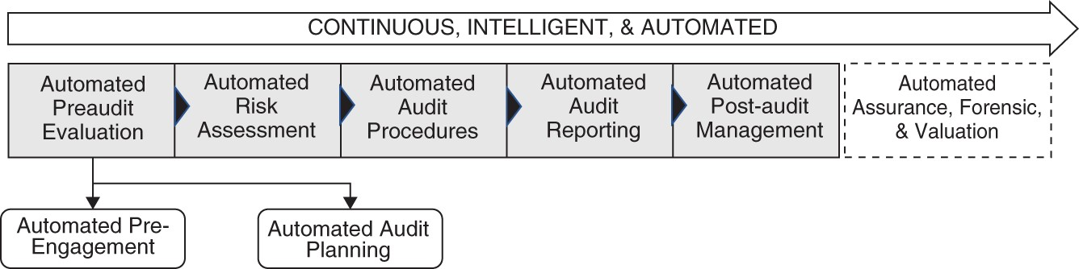
FIGURE 7.1 Automated Preaudit Evaluation

AUTOMATED PRE‐ENGAGEMENT
The goal of pre‐engagement activities is twofold: (1) to understand client desirability, and (2) to develop the engagement letter and agreement.
Understanding client desirability means to assess whether the audit firm wants the prospect as a client or not. There are many reasons why an audit firm wouldn't want a firm to become a client. For example, if the previous auditor abruptly resigned from the engagement, or the client has entered a new highly risky business, or the client has promoted or hired a management team that has a record of bad management and ethical compromises, or the client's management team has criminal record, or if the audit firm has a significant independence issue, then an audit firm may pass on the opportunity. In addition to those factors, the client may have legal or regulatory issues, an overly complex business model, or other such issues that may make it unattractive for the audit firm to conduct business with.
Once the audit firm has overcome the desirability issue and has determined that it will be acceptable for the firm to be the auditor of the prospective client, the audit firm can proceed to develop the engagement letter. In addition to the traditional items like objectives, responsibilities, etc., the engagement letter identifies constraints or limitations in the engagement and the expected financial arrangements (i.e., the auditor's fee).

AUTOMATED AUDIT PLANNING
This subprocess includes staffing, early stage analysis of risks, internal assessment, schedule development, specialist assessments, and most importantly understanding the financials, risks, and strategy of the firm.
While risk assessment is part of audit preplanning, from an automation perspective it is a broad area that I cover in the next two chapters.

AUTOMATED PRE‐ENGAGEMENT ACTIVITIES AND WORK TASKS
As shown in Figure 7.2, automated pre‐engagement subprocess is composed of three primary subprocesses and activities:

Activity 1: Automated Acceptance and Continuance of Audit Activity 2: Automated Ethics and Independence Evaluation Activity 3: Automated Contractual Agreement
Each of the three activities can be further segmented into lower level tasks:

Acceptance and Continuation of Audit: This activity is based upon determining if the client is desirable and the audit firm will accept or continue with the client. This includes specifically looking at the following work‐tasks:
Management team background checks: This agent performs background checks on the prospective client management team and uses public information to do that.
Client financial background check: This agent specifically looks at the financial performance of the firm. Most of the analysis is numerical (i.e., it uses financial information such as ratios and data from the financial statements); however, some of the more insightful parts are also based upon analyzing textual information such as analyst reports, news, articles, online comments, and general sentiments of various stakeholders. The agent also looks at the industry benchmarks.
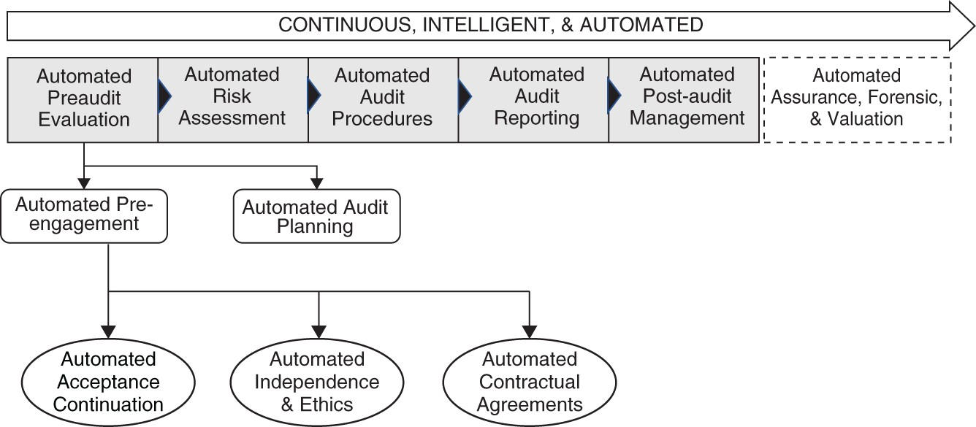
FIGURE 7.2 Pre‐Engagement Activities
Client culture assessment: Like the MIT Culture 500 product mentioned above, this agent performs various cultural assessments.
Client conflict patterns (e.g., lawsuits): This agent looks at the various lawsuits the client is involved in as well as the general level of conflict that exists with various

stakeholders (e.g., climate change or human rights activists).
Relationship assessment: This agent compares the cultures of the audit firm and the culture of the client to observe if a reasonably sound relationship potential exists or not. If based upon the relationship assessment agent and other agents, the audit firm discovers that the client will not allow the auditor to perform audit with confidence and tenacity that is needed for a quality audit, it will be better to pass on the opportunity.
Extraordinary business risks: This agent looks at the extraordinary or abnormal risks faced by the client.
Fraud index: This agent uses the information from various sources (including the financial data) to assess the likelihood of fraud in a firm.

Ethics and Independence Evaluation
Independence in form evaluation: This is an inward‐looking agent that evaluates the audit firm to assess whether the firm is independent in all respects. It also focuses on the auditors.
Independence in appearance evaluation: This is also an introspective evaluation agent that looks at whether the audit firm or any of its auditors have violated the independence in appearance requirement.
Ethics: This agent ensures that ethical standards are maintained, that ethics trainings are completed, and that ethical conducted is pursued in all matters.

Contractual Agreement
Special requirements assessment: This agent understands the special needs of a client and determines the type of extra help or specialist needed.
Cost assessment: This agent helps evaluate the cost of the audit.

As you can observe above, our concepts from Chapter 6 about planning have come in handy. We now have the entire process segmented into subtasks, activities, and work‐tasks. The work‐tasks are where automation materializes.

PRE‐ENGAGEMENTSADAL
In the fourth stage of planning, we take each of the work‐tasks and develop the structure of the intelligent agent by analyzing Sense, Analyze, Decide, Act, and Learn. While in the actual implementations of intelligent audit automation each of the above work‐tasks will require a comprehensive evaluation, in this book I will present only few examples for illustration purposes. The ones I explain below will cover large areas and other SADAL analysis can be patterned after them.

Pre‐Engagement SADAL for Background Analysis
Here, I will present a higher-level SADAL model for background checks. From this higher‐ level model, you can extract many applications of background checks. Background checks can

apply to individuals (management teams of prospective clients, audit staff, partners, etc.) and can apply to entities (firms, business units, etc.). The goal of a background check is to give us a profile of the individual that can help answer the question: Is this person credible for the purpose he or she is being placed in charge or being held responsible for? It can also answer a related question that if a certain responsibility is assigned to a person, what could be the areas in which he or she is most likely to fail (intentionally, for example, due to moral weakness, or unintentionally, that is, due to being unskilled, incompetent, or negligent). At this stage the background check is performed using only publicly available information.
In addition to formal data available on individuals (e.g., credit, criminal, legal), these days we leave a trail of our activities on the web. This may include our articles, speeches, presentations, social media updates, organizational memberships, photos, comments, likes or dislikes, reviews, and so on. Our residential addresses can also reveal data about our estimated monthly mortgages or rents. All of that data is minable and becomes a source of providing great information.
For illustration purposes, I will present a general agent analysis. Readers can abstract the concepts to develop more customized applications for their specific uses. While audit firms are familiar with the criminal background checks, the SADAL agent presented in Table 7.1 takes those checks to the next level. We are designing an agent that will perform continuous background checks. Recall that such background checks can be performed for employees, management teams, etc. These capabilities should be deployed in audit firms on a proactive and preemptive basis. This means to preemptively start building such analytical capability as soon as the firm believes that a company may become a prospective client.

TABLE 7.1 SADAL Analysis for Background Checks

Sense | Analyze | Decide | Act | Learn
Data: Criminal, legal data (publicly available)  Previous employment data  Previous publicly disclosed sale/purchase of equity  Previous legal data | Look for criminal behavior and activity  Identify deception- related personality traits  Identify fraud- related personality traits | Decision to hire or not hire OR decision to accept a client or not  Recommendation to investigate more | Provide ongoing feedback to the audit leaders  Provide feedback to the engagement staffing/HR department | Learn to perform the background checks  Learn to classify candidates on various output dimensions of criminal behavior, deception traits, fraud traits
Social media
LinkedIn
Articles
Interviews

Pre‐Engagement SADAL Analysis for Management Profile
Creating and keeping a management profile of prospective clients is an important consideration. It enables auditors to develop a deeper understanding of client executives' motivations, behaviors, and personalities. As stated before, it can give the auditor warning signs for potential misconduct. Using the language from molecular biology, these analyses are in vitro and noninvasive. The invitro part signifies that they can be conducted outside the client organization, in a lab. The noninvasive means that only public data is used to perform them.
Building a management profile requires analyzing publicly available information about the management teams. Some of the nonstandard signals hide in the communications given out by the management teams. Many communications, for example, earnings calls, interviews, articles, and others, give out significant information about the management team. It is better that these analyses are performed first at an individual level, if possible, and then the team dynamics can be explored to identify if the management team risks are augmented by the combination of traits that could indicate trouble. For instance, the following rules can guide risk assessment:

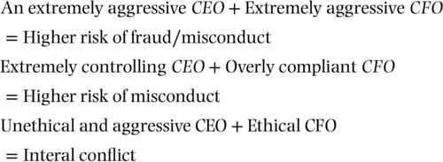
The deception analyzing agent shown in the SADAL analysis in Table 7.2 is built using the earnings call data (note that similar agents can be built for disclosures, financial statements, or other communications analysis).
Natural language processing methods are used to analyze the text. The text or communications are analyzed for patterns of language and then classified based upon either previously known usage of certain words, styles of speaking, and vocal features as being associated with deception and lying, or a sample of communications is taken from known cases of management fraud. Once the agent learns how to spot deception, it can be used to analyze earnings calls (or other communications) to identify deception.
TABLE 7.2 SADAL Analysis for Deception Analysis

Sense | Analyze | Decide | Act | Learn
Data: Earnings calls data Sensor: Voice recorder, digital file, text | The words that indicate deception or obfuscation  The language patterns  The vocal features | Determine if the vocal, linguistic, and financial information indicates fraud | Update the profile of the prospects  Send results to agent that analyzes team dynamics | Learn the language and vocal patterns that indicate deception

TABLE 7.3 SADAL Analysis for Audit Team to Client Matching

Sense | Analyze | Decide | Act | Learn
Resumes  Project requirements  Client‐related data  Communications by the staff member  Previous audit reports  Previous audit reviews (internal and external) | Using NLP establish a profile of candidate and a profile of client/audit and determine if the right match:  Qualification  Deceptive Impression Management | Determine if the candidate is the right match for the client assignment.  Predict quality of work/audit.  Identify special areas of weakness. | Notify the engagement leader. | Learn the various capabilities to be able to perform the analysis on an ongoing basis.
 | Situational
 | Industry
 | Client type
 | Personality
 | Interest

EXAMPLES OF MACHINE LEARNING TO IDENTIFY DECEPTION
Larcker and Zakolyukina (2012) performed a study where they used a classification model to classify deceptive discussions during quarterly earnings conference calls. They labeled the data based upon subsequent financial restatements and severity of accounting problems. In their model, language is analyzed for deceptive words. The model found that it predicted better than or equal to prediction by financial and accounting variables. They found that the words used by a CEO and CFO indicate if the executives are trying to hide something. The methods employed include searching deceptive words as included in a custom dictionary and then looking at the frequency of their usage in statements. Another method employed is to use Bayesian classifier (introduced in Chapter 5). While evaluating disclosures, researchers Humpherys, Moffitt, Burns, Burgoon, and Felix found that “fraudulent disclosures use more activation language, words, imagery, pleasantness, group references, and less lexical diversity than nonfraudulent ones. Writers of fraudulent disclosures may write more to appear credible while communicating less in actual content.” (Humpherys et al., 2011).

In addition, Support Vector Machine algorithms have been used for detecting fraud (Pai et al., 2011), Researchers found that artificial neural networks (ANNs) perform better than other methods. As technology has advanced, now deep learning is being applied to the deception problem. In addition to linguistic characteristics, psycholinguistic features and syntactic complexity were used. As micro‐expressions, hand gestures, and other visual features are now analyzed from videos, multimodal features are being used to train deep learning neural networks (Mendels et al., 2017; Krishnamurthy et al., 2018). This means that in addition to language, body language and gestures can also be analyzed to detect deception. That takes the deception evaluation to the whole new level. In fact, financial fraud detection effectiveness may increase by simultaneously considering vocal, linguistic, and financial cues (Throckmorton et al., 2015).

AUTOMATED AUDIT PLANNING ACTIVITIES AND WORK TASKS
The audit planning happens after the client and the auditor have contractually agreed for the audit. The goals of planning in audit are:

To evaluate and understand the target client's business and industry To develop insights into business, organization, and strategy
To understand the operations and operational methods To examine the accounting and financial systems
The preplanning process sets the tone of the audit engagement and enables the auditor to discover important issues early on and includes the following activities: Staffing, Project Management, and Strategic Review, and Intelligence (Figure 7.3).

Activity 1: Staffing
For as long as humans are relevant for the audit, assessing staff competency and ensuring that the project is staffed with the best people will continue to be relevant. The automation focus for staffing is on the following three work‐tasks:

- Competence and Capability Assessment: This agent looks at the competence and capabilities of the audit staff and also determines if they are the right match of the client needs. Note, this implies that client needs are determined and expressed in a detailed manner.

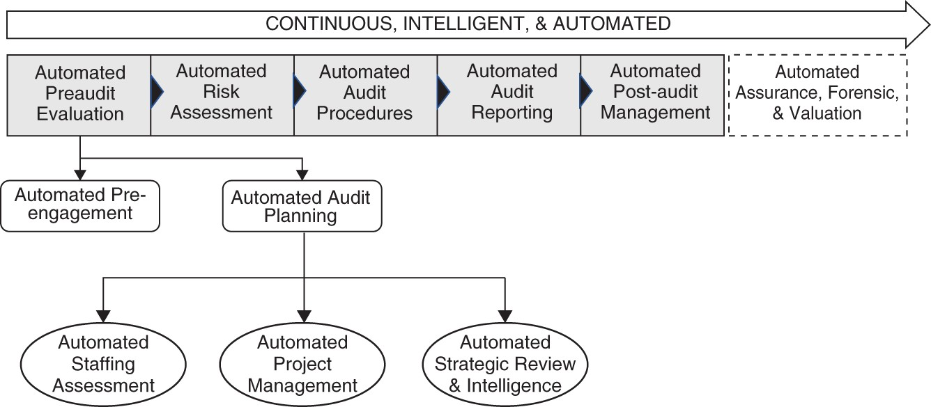

FIGURE 7.3 Audit Planning
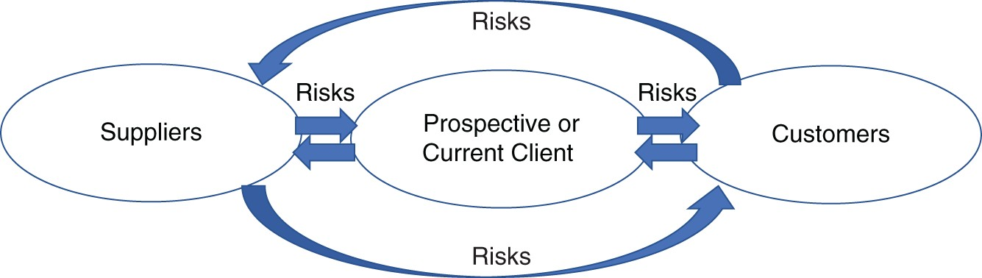
FIGURE 7.4 Value Network
- Independence Assessment: This agent evaluates the independence of the auditor staff that begins work on the audit. Unlike the independence evaluator in the pre‐engagement evaluation (which used public information for evaluation), this agent constantly evaluates the audit staff to identify if risk of independence compromise is increasing.
- Professional Judgment Assessment: This agent looks at the professional judgment and professional skepticism as personality traits. It evaluates personalities of the auditors to understand the propensity of compromising professional judgment.

Activity 2: Project Management Automation
This activity involves general project management. Notice that while these tasks seem to be more manual, significant automation efforts are being applied to automate project management.

Partner Management: This agent helps manage the partner relationships. This includes the planning of audit components, allocation of work, setting expectations, resolving issues, etc.
Work Management: This agent is a project management and work management agent. It works with Partner Management in areas where external coordination with third-party

experts or partners is needed.
Scheduling: This agent manages and schedules tasks.

Activity 3: Strategic Review and Intelligence
This activity involves performing a comprehensive review of the client's business, industry, strategy, and financials. In addition, it can involve other audit‐related evaluation (e.g., understanding the audit framework).

AUTOMATED AUDIT PLANNINGSADALS
The intelligent automation preplanning environment is composed of several agents working together to enable rapid and comprehensive assessment and effective proposal, preplanning, and understanding of an audit. In this environment, the auditor must gain insights about herself and her team, as much as about the client. The environment is subdivided into four broad capability areas:

- Competence and Capability Assessment
- Independence Assessment
- Professional Judgment Assessment
- Preplan Intelligence

Competency and Capability (C&C) Assessment Toolkit
As the Big Four were rocked by scandals and audit quality disasters in the UK, Marriage and Ford analyzed the problems and stated that price gouging was not as big of a worry as the dominance of the Big Four leading to “slapdash audits conducted at minimal cost by inexperienced staff” (Marriage and Ford, 2018). Selecting competent and capable individuals as members of an audit team is critical for audit success. Despite the technological advances, the human auditor is expected to stay relevant and important for audit success. Many audit failures happen when, either due to time pressure or resource availability issues, wrong team members are picked and deployed. Competency is related to factors such as work ethics, personality, trustworthiness, and managerial capabilities. Capability refers to the experience and educational experience that qualifies the auditor to conduct an audit. Competency and capability are assessed from education, experience as an auditor, experience in an industry, experience with a client, and experience with the specific type of audit needed. The goal of competency and capability assessment toolkit is to ensure that the auditors are capable, knowledgeable, and competent to conduct an audit. The artifacts that accomplish this are composed of several components and use multiple agents to:

Identify specific attributes of competency and capability by using natural language processing.
Determine if these factors can predict the audit performance risk.

The first problem area strictly deals with evaluating the experience of a covered or uncovered member of an audit or assurance team. Various intelligent utilities check for different dimensions that contribute to competency and capability. The analysis performed goes beyond the overly simplistic analysis performed in many firms that use resume, employee reviews, and recorded experience from a firm's databases. The core idea is to enable a firm to identify such patterns that are not easy discernable from rudimentary analysis.
The history of previous audit and audit teams includes binary or class data on the success of audits and auditors. If such data is not available, it will be helpful to label that data by asking partners or others to report on the relative (categorical) or binary success of the audit.
Regulators, such as PCAOB, can also provide such information. The starting point is to discern which of the audits were successful and which were not. That information can be considered as the output variable or the dependent variable to the wide set of inputs that go into making audit successful or not. For the specific utility under discussion in this section, the input variables are focused upon the human element (i.e., the human auditor). Once we know which audits were successful versus unsuccessful, several types of information can be extracted from them.
Previous successful/unsuccessful audits provide a plethora of information on the firms in which the audit was conducted and of the people involved in the audit. When unsuccessful, the general response of audit firms is to fire the people involved and then try to forget as if it didn't happen. In reality, each audit gone bad or good provides some critical information about many dimensions of the audit. That information can be used to plan future audits. Specifically, we can learn about the type of the resources used – hence the capability and competence evaluation.
This agent is multimodality automation (i.e., deterministic and machine‐ learning–based automation). In deterministic evaluation it looks for some specific criteria – for example, using RPA to identify if the potential staffing candidate has a CPA or not, years of experience, client-specific experience, audit area experience, or industry experience. On the machine learning side, the agent should be able to conduct far deeper evaluation about both the client needs and the candidate's competency and capabilities.

Agent Adds Details to Experience
Situational experience implies the experience of an auditor from handling business circumstances, states, and situations that were encountered in client audits. For example, knowing that an auditor audited Company A from 2008–2010 is one thing. Understanding that the audit was conducted when the firm was undergoing restructuring, was being run by new management team, and had suffered huge losses another. Situational experience looks for such patterns. The situational categories refer to a state that a company was in when the audit was conducted. The state implies the presence of business conditions that prevailed during the time of the audit.
Situational classification determines categories such as pre‐IPO, post‐IPO, bankruptcy, reorganization, new leadership, and new product launch.
The C&C agents use data from various internal and external sources and determine if the auditor has the relevant experience for an audit engagement. Using natural language

processing, the C&C Assessor evaluates the patterns of interest. It seeks to classify the unique client situations from the past and relate them to the times the auditor was involved with the client.
Notice that while the situation is specific to a client, the role played by the auditor in the engagement is specific to the auditor.
Situational inputs include details about the audit client. Such details might include factors such as industry, client type, complexity of client, challenges of client, and other details such as unique situation of clients, including factors such as pre‐IPO, post‐IPO, or bankruptcy. As previously mentioned, some of the data (e.g., client industry) could be pre‐classified and can be directly extracted from the databases. But to learn about the specific situations of the audit, workpapers or other areas where such strategic insights were recorded can become an excellent source of information. The attributes (inputs) for this could be notes from previous client engagement, or information (news, articles, commentaries, analyst reports) published about the client during the timeframe when the audit was conducted.
The audit team members who participated in that audit can be asked to comment on the specific parts that were applicable to their specific assignment in the audit. Senior members, especially partners, are usually part of the entire audit and hence knowledgeable about such situations.
Another issue of matching a client with a candidate is industry classification and candidate experience. Such experience is often stored in the database of the firm where client companies are classified by industries. Since these days firms can have many different business segments and units, it is important to make sure that the candidate had experience in the exact area where prospective client audit needs help. Hence, just because client information is maintained in a firm's company records does not imply that an industry match can be established. Experience from previous audits must discern specifics of the industry. For example, if GE was the client, we need to identify the exact areas of audits – business unit, department, functional area – that the employee worked in. If such records are not kept, or the degree of depth is not maintained, machine learning can be used to establish such details by datamining documents from previous audits.

Agent Looks at the Qualifications
Qualification assessment is performed by using the data from resumes, certifications, and internal testing. The goal of the agent is to determine if the candidate or potential audit staff member is qualified or not. The learning environment set up to perform these analyses is typically composed of the following features:

Target staffing description
Applications by candidates to staff a position Candidate background and experience Candidate resume
Client description Client industry

Candidate skills (candidates and skill tags relations) Generic skill tags
Skills are often taken as a collection of skills represented in text where a person can have many skills and one skill can be described by many words. One way to capture skills is to form canonicalized sets of skills as representatives of skills required to perform a job (Matos Pombo, 2019). A specific combination of skills can be consolidated to represent such a collection of skillsets. For example, it may include factors such as skill tags, experience level, extracted skills, or extracted additional skills. Other data, such as about compensation, educational background of the candidate, distance between residence and client audit site, and other such factors are preprocessed to be used as inputs. This can be used to match the client with the audit staff.
Note that since audit team members may update their data as they acquire new experience, and the HR system may only have the most recent data, if we are using the experience generator from prior years, we may have to shave off some of the recent experience of the audit so that his or her experience is rolled back into the time when he or she performed the audit that is being included in the training data.

Agent Looks for Deceptive Impression Management Sanitize and De‐ DIMing
DIM refers to Deceptive Impression Management. DIM, in the context of employment and project assignment, happens when job or project candidates engage in deceptive practices by intentionally distorting their experience and qualifications on resumes, records, interviews, and other documents that are used to make sense of their educational and experience background. The de‐DIMing agent uses natural language processing to understand the use of words that indicate deceptive practices. Misstatement or distortion can be intentional or unintentional.
Unintentional distortion happens when a candidate believes that he or she has experience in doing something but he or she hasn't done it, or done it at the level he/she believes.
Misstatement happens when a person intentionally claims that he or she has experience when they have not performed the required tasks to acquire the experience. It can happen when someone embellishes or decorates experience, or when the auditor creates stories about experience they don't have, or when a person configures their experience to the specific requirements of the recruiter regardless of the veracity of the claims, or when a person conceals important facts about their experience (Levashina et al., 2009; Levashina and Campion, 2006; Levashina et al., 2014; Levashina and Campion, 2007). Research shows that deceptive tactics, including exaggeration or lies, on resumes are a function of word usage. For example, usage of fancy or too exciting words used to represent achievements or family are often used as proxies or markers to identify distortion.
There are two ways to build the agent to track this (Auer, 2018). The first way is using dictionaries in which predefined content (words) is used to analyze resumes. This is a closed‐ vocabulary approach where word lists (user‐defined dictionaries, lexica) are developed based upon psychological factors, and word counts (total word frequency) in text are analyzed based upon those to determine the pattern. The obvious constraints in this approach are, first, that the

context of the usage of a word is not reflected in the analysis and, second, when you build a dictionary you already assume that you know the features (a priori).
The second method is to use open‐vocabulary techniques to predict words and phrases (n‐ grams) relevant to the topic. A method known as latent Dirichlet allocation (LDA) is used (Blei et al., 2003, 2010). This method is based upon understanding the relationships between words by calculating their distance from each other by looking at the usage patterns. For instance, the word mug is closer to coffee than water, and the word glass is closer to water, juice, and milk than coffee.
Using the above methods, agents can extract patterns from resumes to determine if the candidate is using deception in the resume.

Agent Evaluates Independence
Many large company audit committee chair positions are staffed by Big Four alumni. Nearly all large audit firms provide consulting services to audit clients. The independence assessor is a utility that tests for an auditor's independence. The utility takes input from various sources, including social media (e.g., LinkedIn, Facebook), to evaluate whether the auditor has made comments about the firm, the management team, or products of the firm. Using frequency of words, one can measure whether the auditor has expressed personal opinions about the client or its management team, had relationship with the client, or has any other ideological connection with the auditee. The approach can expand to include relatives of the auditor for evaluating conflict of interest – if needed. The agent can also identify relationships between the auditor and the audit committee. AI is now being widely used in performing background checks. Similar concepts can be applied to identify such relationships. The vast amounts of data these days can be used to track relationships between related parties.
Note: A regulator (e.g., PCAOB) can also use similar agents to scan the Internet to pick up news, comments, social media entries, or press releases about the auditor conducting consulting business with the client.
Besides performing searches or deploying closed‐vocabulary dictionary‐based models to evaluate occurrences of joint mentions or words, a more reflective system can also be designed. For example, data can also provide insights about “values and orientation” matches. For example, these days companies often take positions on social or political issues.
Understanding those positions and then evaluating whether the auditor may have a conflict with the political or social positions is a major concern for evaluating independence. The Independence Assessment may reveal that a member of the audit team is either too conservative or too liberal, or too religious or anti‐religion, and may hold a too accepting or rejecting attitude toward the client. For instance, the Vatican hired PwC in 2015 for audit and then in 2016 suspended the audit. The Vatican's chief auditor, Libero Milone, informed the
Financial Times that he was forced to resign because he requested information about assets held by Vatican in Switzerland and that some people in the Vatican felt uncomfortable about that (Johnson and Mancini, 2019). Vatican representatives denied the allegations and counter‐ alleged that Milone was accused of spying on the private lives of cardinals and others, and that is why he was asked to leave. The Financial Times reported that audit was part of the efforts by Pope Francis to bring transparency to the church; however, his efforts were being resisted internally. One can appreciate the internal conflict an auditor might face if he or she

has to be placed in this situation and has to tread through the complexities involved. Can one maintain independence?
While search algorithms are used to scan the networks for independence assessment, data from previous engagements can be extremely valuable to develop an agent to evaluate independence.

Professional Judgment
Autonomy, an upcoming UK firm, was sold to Hewlett‐Packard in 2011 for $11.7 billion. Soon after the purchase, HP had a write‐down of $5 billion. A fraud investigation followed. From the United States to the United Kingdom, courts got involved and after years of investigation the FRC (Financial Reporting Council) claimed that they found that Deloitte auditors had “oneness” with Autonomy leaders and Richard Knights, the partner who was in charge of Autonomy audit, “consciously lost his objectivity,” and was “reckless” and “seriously misleading” (Kinder, 2019). Clearly, over a period of five years of the engagement, Richard Knights may have made several comments, written emails and reports, and covered for the client. Was it possible for the firm to know that he was getting too close to the client? Was it possible for the firm to get an early warning sign that his behavior indicates that he is losing his independence? Was it possible that the firm may have recognized that due to his personality he was more inclined to lose professional skepticism? The combination of the agents discussed in the previous section and this, achieves that. It is possible to get early warning signs when an auditor begins to lose his or her independence.
The emails, articles, and almost all words, either said verbally or written, can provide tremendous insights into the personality of a person and his or her judgment in various situations. Tausczik and Pennebaker's early groundbreaking work using closed‐vocabulary (dictionaries) to classify various personality states can be applied to evaluate professional judgment (Tausczik and Pennebaker, 2010). However, open‐vocabulary–based models can work wonders. The professional judgment agent uses the written communication to categorize the speech pattern of people to determine their personality traits. While this is by no means a science, it can provide some level of assurance to determine if the person possesses behavioral traits that give the person the right professional attitude toward audit. As covered in research by Mairesse, Walker, Mehl, and Moore (Mairesse et al., 2007) the language used by people in general can provide some information along the following personality traits (Mairesse et al., 2007):

Extraversion vs. Introversion (sociable, assertive, playful vs. aloof, reserved, shy) Emotional stability vs. Neuroticism (calm, unemotional vs. insecure, anxious) Agreeable vs. Disagreeable (friendly, cooperative vs. antagonistic, faultfinding) Conscientious vs. Unconscientious (self‐disciplined, organized vs. inefficient, careless) Openness to experience (intellectual, insightful vs. shallow, unimaginative)
Mairesse et al. classify along the above traits. However, in addition to classification, they used regression (see Chapter 5) and ranking models.

Add to the above the data from auditor's calendar (time spent, calls, timing of calls, dinners, etc.) with a client and the expense reports (type of travel and entertainment activities charged to the project) and emails to the client (management teams) and the firm can start to get an indication if the auditor is crossing the independence redline.

Personality
Determining personality is a classification exercise where management teams' or auditors' personality assessments are made from using text data. Using the data from their speeches, written texts, and other sources, various personality classifications can be made.
A 2011 study from neuroscience revealed a close relationship between written communications and regions of brain that exhibit personality traits (Adelstein et al., 2011). That provided a physiological (brain regions) link between personality traits and written communications and therefore enables us to link written communications directly with personality traits.
Imagine the sources of textual data that we can have these days, from articles to interviews, and social media to emails. Several studies have attempted to extract personality traits from social media text and classify them along the Big‐Five personalities (openness, conscientiousness, extraversion, agreeableness, and neuroticism) and Eysenck's Three Factor personality mode (Mairesse et al., 2007; Sewwandi et al., 2017; Tandera et al., 2017). While text‐based features show promising results, adding other features, such as hashtags, avatar choices, and other text features, provides even deeper insights (Wei et al., 2017).
Going beyond pictures, facial images are also being used to predict personalities (Ilmini and Fernando, 2016). Both ANN and support vector machines were used by Ilmini and Fernando to classify facial image to discover personality.
In 2017, Stanford research focused on using deep learning to classify structured written content by Myers Briggs Personality Type (MBTI) (Ma and Liu, 2017). Using novels as the input, and the known personalities of the authors by MBTI, they used neural networks to discover authors' personalities from their work.
With the advances in technology, deep learning can enable multimodal data to predict personality (Kaya and Salah, 2018). Multimodal data includes text, video, and audio to get a sense of personality. Videos and images can provide significant feature inputs like facial expression, facial attributes, gestures, and age/sex of a person.

Understanding Client Strategy
When scandal after scandal erupted in UK Big Four audit firms, the UK Parliament decided to take action (Parliament, 2019). The idea was to create more competition and improve the quality of audit. As the search for solutions continued, suggestions were made to include the next-tier firms to perform group audits. In the January 2019 hearing organized by Parliament, two separate sessions were held. The second session was when the Big Four were called to testify about the various proposals on improving audit quality. The first, and perhaps more interesting, session was with the next‐tier firms and included BDO and Grant Thornton. The parliamentarians were interested in understanding the criteria that audit committees are interested in evaluating when they hire audit firms. Scott Knight, head of Audit and Assurance

at BDO, answered that question by stating that the audit committees seek audit firms that can choose “the right team and right personalities,” and that can “understand the business,” and go “under the skin of the business” and develop “industry benchmarks.” I believe his answer pretty much sums up the importance of understanding the business, business model, business strategy, and financials of the client. Such an understanding cannot be superficial or at a surface level. Scott Knight's words, “under the skin of the business,” imply developing a truly comprehensive and deep understanding of the client's business.
The agents I introduce in this section do just that. As you can tell, understanding a client's business is not an easy task. There are so many avenues of developing that understanding. As we develop these analyses, it also enables us to identify patterns that can show us the overall complexity of the organization and/or identify risks.

CLIENT BUSINESS STRATEGY AGENTS
I will focus more on this in Chapter 8, but I would like to provide some context to how to accomplish this. The Client Business Strategy includes three agents:

- Agent that helps understand the financials
- Agent that helps identify the value chain
- Agent that can help understand the competitive dynamics and industry benchmarks

Understanding risks is an important part of this exercise; however, it is discussed in the next two chapters.

Agent for Identifying the Value Chain/Network
In 2016, three professors (from Georgia Tech and Boston University) and a researcher from Instacart develop a computational model of risk diffusion in global supply chains (Basole et al., 2016). Their study had two objectives: “1) Assess and visualize the impact of network structure on risk diffusion and supply network health. 2) Determine the impact of subtier visibility on reduction and potentially mitigation of cascading risks.” They built their data sets using four sources. First, they identified a list of electronics businesses by revenues using EB300. Then they got data on the businesses they had identified from Thomson Reuters Securities Data Company (SDC). This database contains information on relationships such as alliances, supplier, R&D, licensing, marketing, and manufacturing. They then augmented that with data from Connexiti, which also has information on suppliers and customers of companies. Finally, they got the financial data from Compustat. Using these data sets, they developed a two‐tier supply network of the supply chain. Using the AB agent‐based simulation they performed the risk analysis. Basole et al. (2016) used z‐scores and simulated the environment composed of agents (companies, customers, suppliers) using a model borrowed from biology (epidemiological model).
This offers a great example of the data‐centric modeling that audit firms need. A similar concept can be deployed to first build the value chain of the prospective and current audit clients. This value chain represents the value creation process in a firm. The process starts by first capturing the broad network of key relationships the firm has. A separate modeling

exercise is used to model the internal operations of the firm. Once the network is established, additional risk drivers such as supply‐side risks, process‐side risks, demand‐side risks, operational risks, disruption risks, and other risks can be added to the model.
Once the network structure is set up using tabulated historical data, many deeper insights about the firm and its value chain can be obtained. The model works as follows:

Each firm is an agent.
Using features such as Financial (current ratio, quick ratio, working capital, turnover, etc.) Operational (inventory, inventory turnover, margins etc.), Supply (supply characteristics, prices, etc.) and many other such features.
The output variable can be viewed as adding risk or reducing risk.
Your machine‐learning algorithm will predict the risk for your network configuration.
As an added benefit, meta‐analysis of your client's network can give you other information about your client. For instance, the competitive position of your client in the network, the number of nodes your client has, or the vulnerabilities.
You can add to this text data from various players in the network. The specific focus of the text data will be to understand communications about various strategies.

Agent That Helps Understand the Financials
While a lot of this will be discussed in the upcoming chapters, in this chapter, I will introduce the power of machine learning to analyze and predict the financials. As early as the 1980s, researchers have pointed out the value of having expectation‐based account estimation (Peters et al., 1989). It begins with financial statements from time t, and then looks for quantitative factors that may have impacted a change in accounts; an estimate is produced; and an adjustment is made to develop a financial statement at time t + n. A somewhat related idea explored by some researchers is to use agents to model shadow accounting (Chesney et al., 2017). Shadow or counter‐accounting is when external parties to a company try to create accounting estimates of those things that either the company is trying to hide or is unintentionally not reporting. Activists often use shadow accounting for understanding the environmental or human rights impact of a firm's activities. Both of these examples shed light on something important. It is possible to build a reasonable estimate of a company's financials (and accounting) by external parties who don't have direct access to internal information. This becomes an extremely valuable tool for audit firms. This means that to provide an estimate of expected financials, an alternative accounting system can be developed outside the client firm. In a way this can be viewed as reverse engineering the accounting system.
This agent is responsible for providing information about the target client business. Since this agent can perform this task constantly, it is not efficient to solely focus it on one firm. To accomplish its task, the agent scans through various types of information and tries to help develop important aspects of expectations adjustment about the client. The core conceptual architecture of the machine learning agent is composed of the utility using input data from various sources, and then classifying it to various outputs.

The input comes from various sources, including news, analyst reports, financial statements, PR announcements, social media, lawsuits, patent filings, or regulator reports.
Output variable is either a binary expected increase or decrease classification, or a more useful estimate of the increase or decrease percentage as a continuous variable from a regression (see Chapter 5).
Note that the output variables can also include other items, such as asset types, culture, management, issues, incentives, or risks. Each of these will be different classifications/regression problems.
Machine learning plays an extremely important role in reverse engineering the accounts based upon the public data. For instance, using social media data one can estimate if the sales (revenues) of the firm may have increased or decreased. In fact, social media is great source of developing key insights into companies. The insights go beyond analyzing the culture and can be used to understand factors such as quality of sales, innovation, new product launches, strategies, management styles, financial performance, and many other areas. When other sources, such as analyst reports and news, are added to social media, even greater insights can be obtained. Several machine learning artifacts can be designed to enable such ongoing analysis, to:

Augment existing analytics based upon financial metrics using machine learning to identify unseen risk from management disclosures, communications, earnings calls, and other information released by the firm.
Enhance insights into the company using content from social media. Evaluate risks and performance potential but also about the management team.
Develop a learning system to understand and study the competitive structure of the industry based upon various drivers such as capabilities, access to capital, innovation potential and other such factors.

Finally, the above information can also be used to determine the complexity of a client. While the drivers of complexity can refer to the business model or asset characteristics of the client, many factors determine that complexity. For example, culture of a firm, leadership style, personalities of leaders, specific situations (e.g., shareholder activism), incentive structures, and financial returns.

Key Points
Audit preplanning and planning are critical steps for audit. The success or failure of an audit greatly depends upon these steps.
Automating these steps requires two types of automations: (1) Automated Preplanning; and (2) Automated Audit Planning.
Automated preplanning focuses on developing capabilities that can help develop information about the desirability of a client included in Automated Acceptance and Continuance of Audit, Automated Ethics and Independence Evaluation, and Automated Contractual Agreement.
Automated audit planning develops insights into business, industry, organization, and strategy of a client, understands the operations and operational methods, and examines the accounting and financial systems and frameworks. At this stage (i.e., early stage of the audit), a sanity check system also works in background and in parallel to formal financial reports, which uses public information to produce expected financial statements.

REFERENCES
Adelstein, J. S., Shehzad, Z., Mennes, M., DeYoung, C. G., Zuo, X. N., Kelly, C., Margulies,
D. S., Bloomfield, A., Gray, J. R., Castellanos, F. X. et al. (2011) Personality is reflected in the brain's intrinsic functional architecture. PLOS ONE. [Online] 6 (11).
Auer, E. M. L. (2018) Detecting deceptive impression management behaviors in interviews using natural language processing. Master of Science (MS), thesis, Psychology, Old Dominion University, [online]. Available from: https://digitalcommons.odu.edu/psychology_etds/70.
Basole, R. C., Bellamy, M. A., Park, H., and Putrevu, J. (2016) Computational analysis and visualization of global supply network risks. IEEE Transactions on Industrial Informatics. [Online] 12 (3), 1206–1213.
Blei, D., Carin, L., and Dunson, D. (2010) Probabilistic topic models: A focus on graphical model design and applications to document and image analysis. IEEE Signal Processing Magazine. (November), 55–65.
Blei, D. M., Ng, A. Y., and Jordan, M. I. (2003) Latent Dirichlet allocation. Journal of Machine Learning Research. [Online] 3 (4–5), 993–1022.
Chesney, T., Gold, S., and Trautrims, A. (2017) Agent based modelling as a decision support system for shadow accounting. Decision Support Systems. [Online] 95110–116. Available from: http://dx.doi.org/10.1016/j.dss.2017.01.004.

Humpherys, S. L., Moffitt, K. C., Burns, M. B., Burgoon, J. K., and Felix, W. F. (2011) Identification of fraudulent financial statements using linguistic credibility analysis. Decision Support Systems. [Online] 50 (3), 585–594.
Ilmini, K. and Fernando, T. (2016) Persons' personality traits recognition using machine learning algorithms and image processing techniques. Advances in Computer Science: An International Journal. 5 (1), 40–44.
Johnson, M. and Mancini, D. P. (2019) Ousted auditor says he got too close to secret Vatican accounts. Financial Times.
Kaya, H. and Salah, A. A. (2018) Multimodal personality trait analysis for explainable modeling of job interview decisions. In Explainable and Interpretable Models in Computer Models and Machine Learning (eds. H.J. Escalante et al.), 255–275. Switzerland: Springer Nature.
Kinder, T. (2019) Deloitte was too close to Autonomy, regulators claim. Financial Times. 11 October.
Krishnamurthy, G., Majumder, N., Poria, S., and Cambria, E. (2018) A Deep Learning Approach for Multimodal Deception Detection. [Online]. Available from: http://arxiv.org/abs/1803.00344.
Larcker, D. F. and Zakolyukina, A. A. (2012) Detecting deceptive discussions in conference calls. Journal of Accounting Research. [Online] 50 (2), 495–540.
Levashina, J. and Campion, M. A. (2007) Measuring faking in the employment interview: Development and validation of an interview faking behavior scale. Journal of Applied Psychology. [Online] 92 (6), 1638–1656.
Levashina, J., Hartwell, C. J., Morgeson, F. P., and Campion, M. A. (2014) The structured employment interview: Narrative and quantitative review of the research literature.
Personnel Psychology. [Online] 67 (1), 241–293.
Levashina, J. and Campion, M. A. (2006) A model of faking likelihood in the employment interview. International Journal of Selection and Assessment. 14 (4), 299–316.
Levashina, J., Morgeson, F. P., and Campion, M. A. (2009) They don't do it often, but they do it well: Exploring the relationship between applicant mental abilities and faking.
International Journal of Selection and Assessment. [Online] 17 (3), 271–281.
Ma, A. and Liu, G. (2017) Neural Networks in Predicting Myers Brigg Personality Type From Writing Style. 1–9.
Mairesse, F., Walker, M. A., Mehl, M. R. and Moore, R. K. (2007) Using linguistic cues for the automatic recognition of personality in conversation and text. Journal of Artificial Intelligence Research. [Online] 30, 457–500.
Marriage, M. and Ford, J. (2018) An illusion of choice: The conflicts that mire the audit world. Financial Times. August 8, 2018.

Matos Pombo, L. (2019) Landing on the right job: A machine learning approach to match candidates with jobs applying semantic embeddings. Universidade Nova de Lisboa. [online]. Available from: https://run.unl.pt/bitstream/10362/60405/1/TAA0024.pdf.
McKenna, F. (2018) KPMG turned to Palantir to help predict which audits would be inspected. MarketWatch [online]. Available from: https://www.marketwatch.com/story/kpmg-turned-to-palantir-to-help-predict-which-audits- would-be-inspected-2018-06-26.
McKenna, F. (2019) The KPMG cheating scandal was much more widespread than originally thought. MarketWatch [online]. Available from: https://www.marketwatch.com/story/the- kpmg-cheating-scandal-was-much-more-widespread-than-originally-thought-2019-06-18.
Mendels, G., Levitan, S. I., Lee, K. Z., and Hirschberg, J. (2017) Hybrid acoustic‐lexical deep learning approach for deception detection. Proceedings of the Annual Conference of the International Speech Communication Association, INTERSPEECH. [Online].1472–1476.
Ostrom, E. (2015) Public Company Accounting Oversight Board. [Online] 53 (9), 1689–1699. Parliament, U. (2019) Big 4 accountancy firms questioned on future of audit inquiry [online].
Available from: https://www.parliament.uk/business/committees/committees-a-
z/commons-select/business-energy-industrial-strategy/news-parliament-2017/big-4- accountancy-firms-questioned-on-future-of-audit-inquiry-evidence-17-19-/.
Pai, P. F., Hsu, M. F., and Wang, M. C. (2011) A support vector machine‐based model for detecting top management fraud. Knowledge‐Based Systems. [Online] 24 (2), 314–321. Available from: http://dx.doi.org/10.1016/j.knosys.2010.10.003.
PCAOB (2019) Report on 2016 Inspection of KPMG LLP. Public Company Accounting Oversight Board. PCAOB RELE.
Peters, J. M., Lewis, B. L., and Dhar, V. (1989) Assessing inherent risk during audit planning: The development of a knowledge based model. Accounting, Organizations and Society. [Online] 14 (4), 359–378.
Sewwandi, D., Nugaliyadde, A., and Thelijjagoda, S. (2017) Linguistic features based personality recognition using social media data. Proceedings of the 2017 6th National Conference on Technology and Management: Excel in Research and Build the Nation, NCTM 2017. [Online] (January), 63–68.
Sull, D., Sull, C., and Chamberlain, A. (2019) Measuring culture in leading comapnies [online]. Available from: https://sloanreview.mit.edu/projects/measuring-culture-in- leading-companies/.
Tandera, T., Hendro, Suhartono, D., Wongso, R., and Prasetio, Y. L. (2017) Personality prediction system from Facebook users. Procedia Computer Science. [Online] 116604– 611. [Online]. Available from: https://doi.org/10.1016/j.procs.2017.10.016.
Tausczik, Y. R. and Pennebaker, J. W. (2010) The psychological meaning of words: LIWC and computerized text analysis methods. Journal of Language and Social Psychology. [Online]

29 (1), 24–54.
Throckmorton, C. S., Mayew, W. J., Venkatachalam, M., and Collins, L. M. (2015) Financial fraud detection using vocal, linguistic and financial cues. Decision Support Systems. [Online] 7478–87. Available from: http://dx.doi.org/10.1016/j.dss.2015.04.006.
Wei, H., Zhang, F., Yuan, N. J., Cao, C., Fu, H., Xie, X., Rui, Y., and Ma, W. Y. (2017) Beyond the words: Predicting user personality from heterogeneous information. WSDM 2017 –
Proceedings of the 10th ACM International Conference on Web Search and Data Mining. [Online] 305–314.

OceanofPDF.com

CHAPTER 8
Automated Inherent Risk Assessment
IN A DYNAMIC AND CONSTANTLY CHANGING WORLD, the risk
assessment function in an audit is continuous. Businesses are exposed to risks. The risks that are from the nature of a business are known as inherent risks. Rapid changes in technology, new business entry, regulatory changes, and other such factors can change the inherent risk of a firm. From an audit perspective, inherent risk is part of the total audit risk.

TOTAL AUDIT RISK
The total audit risk is composed of inherent risk, internal controls risk, and detection risk. Inherent risk refers to the risk that an error or fraud will penetrate the financial system without internal controls. The internal control risk comes from management's failure to place, or override, proper controls. The detection risk is specific to the auditor and comes from the failure to detect an error or mistake in an audit. The value of Detection Risk often depends upon the value of Inherent Risk and Controls Risk – the higher the Inherent and Controls risks, the more auditor's testing and vigilance are needed to improve the chances of detection. In this chapter, we will cover various ways to build an Inherent Risk assessment system. The primary design of the system is composed of multiple agents working together to analyze and measure the risk. Each agent is supported by several other agents that produce the baseline data both as inputs to develop the agents and also as the user of the system (explained later).

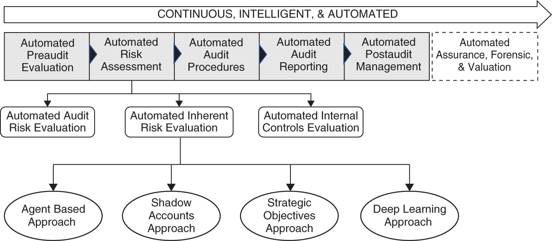

FIGURE 8.1 Approaches to Automated Inherent Risk Assessment The equation for the Total Audit Risk is:
where

IR = inherent risk CR = controls risk DR = detection risk
I am presenting four methods to estimate inherent risk – agent‐based approach, shadow accounts approach, strategic objectives approach, and deep learning approach (Figure 8.1). The first method (agent‐based approach) is the most comprehensive as it provides measures at the assertion level of each major account. Which approach to use depends upon many factors, including the time and investment available for a firm, if the company is developing the system for internal audit versus external audit for various clients, how automated the system needs to be, and the level of sophistication the firm needs.

INHERENT RISK
As the word inherent signifies, inherent risk is the risk of error or fraud penetrating accounts in the absence of internal controls. The risk therefore is

inherent or embodied in the nature of the account and comes from factors such as the form, frequency, size, transactions, training, incentives, business model, and the need for making qualitative assessments.
When we say “inherent,” the term seems to imply characteristics or properties of something. Is a leaf inherently green? Is water inherently wet? A leaf is green based upon what the observer perceives as green and water is wet because the observer (human) finds it wet. The same way, are there properties of something that make it inherently risky – just as water is inherently wet?
For instance, in accounting concepts, cash is viewed as an inherently riskier asset than a building because one can easily steal the cash but not a building. The inherent risk is based upon the characteristic of “ease of transporting a valuable asset.” That characteristic increases the risk for the owner of the asset. From an auditor's perspective, measuring the inherent risk is critical because it is directly tied to the assertions being made by the management related to the financial statements. For instance, the assertions of existence and completeness may make cash more risk prone versus the same assertions for a building. However, consider the same assertions being made about a firm declaring that it is in possession of various buildings on an island that few have heard of. Can we know that the buildings exist as asserted by the company just by looking at the financial statements? Of course not.
Hence, while an account may exhibit in its nature high or low inherent risk, circumstances surrounding the business also impact the inherent risk. The nature of inherent risk varies for accounts by the industry, the type of firm, the accounting systems used, the business model, and the processes.
Furthermore, as the nature of the business changes, the inherent risk for specific accounting systems can change. For instance, if a business does not accept cash and then switches to accepting cash, it has increased the inherent risk of cash.

UNDERSTANDING THE BUSINESS PROBLEM
The process of inherent risk identification is typically a function of the industry, business model, and the operating dynamics of a firm. Experienced auditors are familiar with the risk characteristics of industries and recognize the areas where firms have greater risk. The cognitive work performed by

the auditors is composed of understanding the nature of transactions in an industry and then evaluating whether errors or frauds associated with such transactions are more likely to be included in a financial report or assertion made by the firm. The inherent characteristics of such transactions can be determined by factors such as the following:

Nature of the Account: A more liquid account, e.g., cash, is more vulnerable to fraud.
Account Balance Size: Accounts with a larger balance can have a bigger impact on material misstatement and can be more error and fraud prone.
Transaction Estimation: Transactions in which human subjectivity is used – for example, allocations across different accounts – can be more likely to have fraud or errors.
Business Model: Business models of companies can create more risk for errors and fraud.
Transaction Volume: Accounts with a large number of transactions can be more likely candidates for inherent risk.
Transaction Complexity: Transactions that are more complex (for example, derivates) can have greater risk. This risk comes from inability to value or understand the transaction, which can lead to errors and fraud.
Transaction Treatment: Some transactions can be recorded in ways where they may appear fine but if explored further would show that the transaction should have been recorded in a different account.
Past History: Past history of mistakes and frauds/errors.
Financial Condition as a Motivator: The financial condition of a business that motivates management to commit fraud.

When these risks reach an account level, inherent risk manifests in recording invalid or fictitious transactions or omitting to record factual and legitimate transactions. It can arise from inaccuracies in the transaction amounts and account balances or from classifying transactions in the wrong accounts. It can happen from wrong posting or wrong accounting of the transactions. It

can happen from misleading or incomplete disclosure. It can also arise from when transactions are recorded in wrong time period. All of these can happen as errors or intentional frauds.
The nature of inherent risk is such that the auditor does not control or impact it. It exists and is embedded in the DNA of the firm. An auditor's knowledge of the industry and the firm helps in evaluating the inherent risk. For example, certain accounts may be more prone to management discretion and subjective treatments in certain industries. And, based upon the auditor's previous experience with a client, the auditor may possess information about some accounts having greater risk than others. Automating inherent risk measurement implies we need to somehow model the thought process of the auditor.

AUDITOR'S THOUGHT PROCESS
Based upon the various criteria presented in the previous section, the auditor makes assessments about the risk inherent in the assertions related to the financial statements of the auditee. As such, identifying and measuring inherent risk can be approached in terms of a risk identification, assessment, evaluation, and management problem.
Cognitively, therefore, the auditor processes information about the industry, the firm, and the firm's management team and practices, and all such information is intuitively, or mathematically, translated into a risk estimate (Peters et al., 1989). The measurement could be qualitatively determined and based upon auditor's experience or it can be estimated by applying very rigorous mathematical criteria. Regardless of how it is estimated or determined, the risk estimate can be viewed as the cumulative measurement of values of risk drivers.
Risk drivers are individual risks that collectively lead to the measure of the total audit risk. Recall that the risk manifests in the accounting system and eventually finds its way into the financial statements.
Breaking down the auditor's cognitive thinking, the risk assessment part implies that that auditor maps the financial statements to accounts and accounts to risk factors (Shailer et al., 1998). The risk factors, in this case, are based upon the economic and operating environment of the firm, upon industry dynamics, and upon the management decision‐making (Figure 8.2).

More practically, for our purposes, the problem can be viewed as this: the inherent risk impacts the financial statements and comes from the accounting system and is driven by the risk factors that emanate in the nature and operations of the firm, and its management and industry, processes, and the transactions.
Thus, risk drivers are a function of business model, industry dynamics, regulatory changes, etc., and of the firm-specific dynamics and of the management.
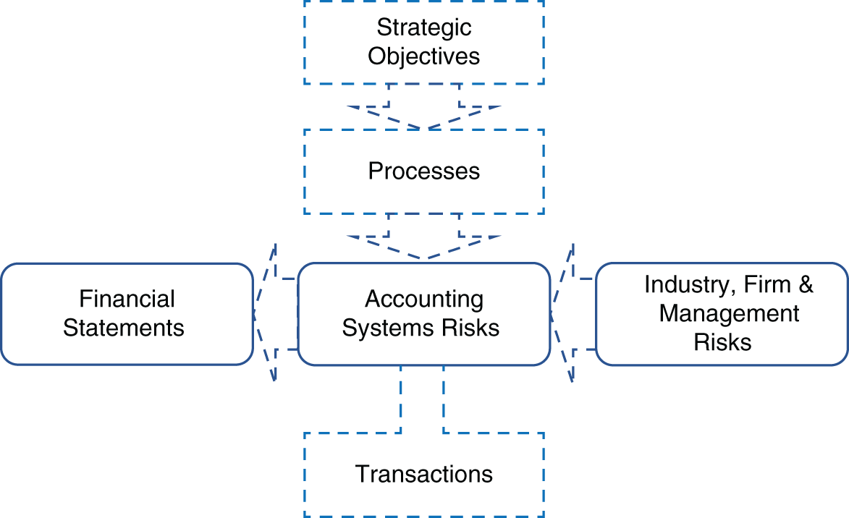
FIGURE 8.2 The Risk Drivers in Inherent Risk

GENERAL APPROACH FOR AUTOMATION
There is a dynamic side to evaluating inherent risk. Typically, auditors use their experience and training to manually estimate the inherent risk. This is usually estimated by the auditors during the engagement. The vibrant and volatile nature of today's business constantly creates new opportunities and risks. In many cases it may even impact the business models of firms. This implies that the nature of inherent risk also evolves the business dynamics and is impacted by both strategic and operational execution decisions.

To automate measuring inherent risk constantly, we use the following general approach:

Start by developing a stationary model of inherent risk. This model is composed of identifying the relationship between assertions and accounts in terms of risks. The beginning state (i.e., static) of the model will establish a relationship between accounts receivable and various assertions.
Each assertion contributes to the risk to an account in different ways. Some assertions may have a lower contribution to the risk than others. For each assertion we identify four assertion risk factors, and then we assign a risk contribution weight to each risk factor. We then rate each risk factor in terms of magnitude (high, medium, low).
Separately, drivers of assertion risks are identified. There are the exogenous and endogenous variables that drive the assertion risk higher in a dynamic risk assessment model.
Consider each of the variables as output variables of a learning system.

Approach 1: The Inherent Risk Intelligent Automation
In addition to an established body of knowledge auditors are guided by experience to determine the inherent risk in an audit situation. The inherent risk is an indirect result of the operational dynamics of a business where an error or fraud can creep into the financial statements in the absence of internal controls. For example, a business which deals with large cash amounts is more prone to problems (mistakes, errors, fraud, etc.) in cash accounts. The inherent risk is therefore based upon the industry and the business model of a firm. The changes in business dynamics can result from changes in the general economic conditions and a firm's participation in new industries.
When approached from an automation perspective, the goal of intelligent automation is to develop an automated learning system that can track, identify, and measure the inherent risk in a firm's audit environment. This learning system should be able to adapt to the changes in the firm's business environment.

This intelligent agent can reduce the time and effort needed to identify and measure areas where a firm has greater inherent risk. It can streamline the process and enable an audit team to quickly assess the inherent risk. It can also be a part of the continuous audit. The value comes from increase in audit efficiency and effectiveness.
As shown in Figure 8.3, where the example of an Accounts Receivable (AR) account is given, the primary model of intelligent automation to measure inherent risk is based upon identifying the relevant assertions to the account, and developing risks factors, drivers, and values for the assertions.
Building an automated inherent risk manager requires the following three steps:

Step 1: Set up the base model
In Step 1, we prepare a base static model of inherent risk. This model links key accounts with assertions and deploys a risk‐based model that identifies the initial states of the risks as understood by the auditors at an initial time t₀.
The process begins by identifying the relevant assertions to an account. Not all assertions are applicable to an account.
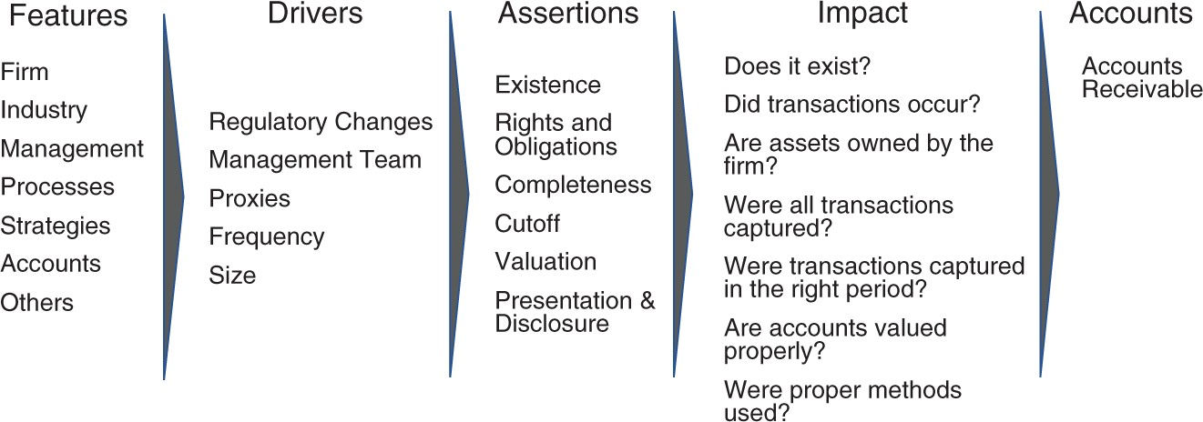
FIGURE 8.3 Accounts Receivable
For each assertion for an account, the risk is measured by the assertion risk factors: Likelihood, Impact, Velocity, and Vulnerability (Table 8.1).
Likelihood measures how likely the specific assertion is of impacting the account; impact assesses the impact of potential dollar impact; velocity can be viewed as a subjective measure of how quickly a misstatement can become material (in other words how rapidly a situation can turn into a

major problem, in minutes, days, weeks, or months); and vulnerability implies the susceptibility of an account to be impacted by special, largely unknown, situations.
For each of the four risk measurements (Likelihood, Impact, Velocity, and Vulnerability), we assign weights to signify the importance (Risk Importance) of each for an account on a scale of 0% to 100%. For example, Velocity could be least important for an account and hence may contribute only 10% to the risk versus Impact and Likelihood could be the most important elements and are estimated at 100%. As shown in Table 8.1, each of the Assertion Risks can be valued as Low, Medium, High (i.e., a scale of 1, 2, and 3). For example, for a major account, “Accounts Receivables” we can identify the assertions Valuation, Existence, Completeness, and Cutoff as of high risk for Likelihood and Impact, with Rights and Obligations and Presentation and Disclosures as low risk.
TABLE 8.1 Measuring Risk

Assertion | Likelihood | Impact | Velocity | Vulnerability
Weights | 100% | 100% | 10% | 20%
Existence | H | H | M | L
Cutoff | H | M | L | L
Valuation | H | H | L | L
Rights & Obligations | L | L | L | L
Presentation & Disclosure | L | M | L | L
Completeness | H | H | L | L
Once those risks are defined as High, Medium, and Low, we can replace the values as 1 for Low, 2 for Medium, and 3 for High (Table 8.2). The total score for each assertion risk can be calculated by multiplying each of the risk scale entries by the Risk Importance and adding across (Table 8.3). For example, the Existence Risk would be 3X100% + 3X100% + 2X10%+ 1X20% = 6.4. The total highest possible risk for that Existence Risk is 6.9 (i.e., 3X100% + 3X100% + 3X10%+ 3X20%). Dividing the calculated risk by the total risk gives the value for Existence Risk.
This model gives us the first state of inherent risk model in a firm. As each major account is linked with assertion risks, it allows us to understand which

accounts have higher inherent risk and why. Clearly, as business changes, a dynamic model is needed to study the changes in risk.
TABLE 8.2 Risk Scale Assignments

Weights | 100% | 100% | 10% | 20%
Existence | 3 | 3 | 2 | 1
Cutoff | 3 | 2 | 1 | 1
Valuation | 3 | 3 | 1 | 1
Rights and Obligations | 1 | 1 | 1 | 1
Presentation and Disclosure | 1 | 2 | 1 | 1
Completeness | 3 | 3 | 1 | 1
TABLE 8.3 Risk Calculation

 | Likelihood | Impact | Velocity | Vulnerability | Sum Risk | Total Risk | Risk
Existence | 3 | 3 | 0.2 | 0.2 | 6.4 | 6.9 | 93%
Cutoff | 3 | 2 | 0.1 | 0.2 | 5.3 | 6.9 | 77%
Valuation | 3 | 3 | 0.1 | 0.2 | 6.3 | 6.9 | 91%
Rights and Obligations | 1 | 1 | 0.1 | 0.2 | 2.3 | 6.9 | 33%
Presentation and Disclosure | 1 | 2 | 0.1 | 0.2 | 3.3 | 6.9 | 48%
Completeness | 3 | 3 | 0.1 | 0.2 | 6.3 | 6.9 | 91%

Step 2: Identify a set of drivers for assertions
Each risk of each assertion can be impacted by various exogenous and endogenous factors. For instance, a sudden surge in frequency of transactions can change the likelihood, magnitude, and velocity of the account. A significant regulatory change can influence the firm's revenues. A winning spree that highlights management achieving shareholder expectations milestones can make management psychologically wired to the idea of continuing the trend even if that means fudging the numbers. These

developments can add or subtract the values of four risk factors for each assertion. In fact, it can even change the importance weights to each. In other words, the risk value of an assertion changes based upon some exogenous or endogenous developments.
In Step 2, we identify those drivers that can increase or decrease the assertion risk. This exercise uses the existing data sets based upon the risk drivers and assertions. These data sets can also detail the errors that can lead to assertion risk increase.
For example, the following factors: obsolescence in inventory, previous misstatements, previous audit results, client operational risk, conflict of interest in management team, non‐routine transactions, litigation, patents, earnings management, profit smoothing, management incentives, management credibility, culture, or ethics.

Step 3: Deploy agents
Each of the exogenous and endogenous factors is monitored by an agent. The agent operates in the relevant environment and learns to study the environment to predict if the changes in the environment will increase or decrease the risk of an assertion. For some agents, the design could be very simple – for example, an agent that can look at the number of transactions in an account can assess whether the transaction frequency is increasing more than the normal or expected transactions. Other agents can be more complicated and may require analyzing complex environments to assess what conditions will impact which assertions.
For example, an agent can use regression to predict the impact of sales forecast on the overall risk. For instance, using regression the agent tasked with the job to analyze the sales of a firm determines the sales volatility to be high. It makes this determination based upon analyzing the social media data about the products sold by the firm. Based upon that, the sales agent predicts that sales can fall in a broad range of plus/minus 28%. This implies that the existence assertion risk for sales could be higher. If the firm's sales are done on credit, this implies that AR's existence assertion risk may also go up. In the sales example the chain of automation will be as follows:

- Predict sales volatility using features from social media.
- Determine the assertion‐risk that it impacts and by how much.

- Make adjustments to the Assertion Risk Factor values.
- Recalculate the inherent risk for an account.

Another, perhaps more sophisticated, agent can be viewed as a multilabel classification problem where the input features for each agent will be used to perform classification into multiple risk drivers. This means that if the agent considers risk to be high, it will use the features to learn to classify the output into one or more classes.

Approach 2: Shadow or Parallel Account
In the previous chapter we discussed about the shadow account. The purpose of the shadow account is to create a parallel account where we can develop financials using external data. Such financial statements can be reverse‐ engineered into approximate account values (for major accounts). Each of the accounts in the shadow account provides a range of possibilities for the actual value. For example, the shadow account may indicate that the sales could be significantly different than anticipated, thus impacting the assertion risks (existence, completeness, valuation) of misstatement.
The process of shadow account development was discussed in the previous chapter. In this chapter I would like to emphasize the importance of using external public information (e.g., social media) to create a map of the actual financial performance of a firm. It is best explained by an analogy of similar use. In 2012, the United Kingdom was hit by severe storms, which led to flooding. It is hard to develop models for surface water flooding due to the variation in the sources of flooding, the structure of the cities (e.g., buildings, street designs, drainage), and many other factors. The lack of hydrodynamic models to study real‐time flooding in urban areas posed a problem in planning for surface flooding. In the UK flooding, as cities and towns were flooded, people provided live accounts of that flooding on social media. By capturing the social media data, researchers were able to develop a real‐time model of flooding, which closely resembled the actual flooding and, hence, had the predictive power (Middleton et al, 2013). The actual urban flooding dynamics were analyzed using the data reported by the citizens who were in the path of the flooding. This is a great example of how data can be used to create shadow accounts for firms.

It is a form of predictive auditing (Vasarhelyi and Kuenkaikaew, 2013) but the difference is that the data used to construct the shadow financials is all acquired from external sources.

Approach 3: Strategic Objectives, Inherent Risk by Firm
Another approach to modeling inherent risk is to directly use the feature data to model inherent risk (Wu et al., 2014; Calderon and Cheh, 2002). Unlike developing agents for each of the assertion risk drivers, in this approach features vectors are directly fed into a neural network to understand the inherent risk in various firms. Modeling the inherent risk is achieved by breaking down the problem into multiple sections, where each section attempts to evaluate the risk related to an engagement. The problem sections raise the questions:

Does a “specific firm” carry greater inherent risk than other firms? Does a management team imply greater inherent risk?
Do certain accounts lead to greater inherent risk?
Does the industry in which a firm operates increase inherent risk? Can we measure inherent risk by account?
The problem can be viewed as a classification problem where based upon various inputs, the learning algorithm will give a classification output of High Risk versus Low Risk. The problem can have many different versions. For example, data about the industry can be used as the input, or management‐team–related data can form the input variables, or firm-specific data can be the basis of discovering the function. Ideally, all of the above are integrated and represented either as a collection of separate calculations that are mathematically linked and consolidated or as a single large deep learning implementation where numerous features can be represented.
The general approach to the problem can be viewed as:

The firm‐level inherent risk is a function of the industry in which a firm operates, the firm's business model, its management team, and its operating

dynamics. The utility we are trying to develop will perform such that if we provide data about a firm, our intelligent artifact can assess for us a high versus low inherent risk client. In advanced versions, the artifact will conduct this surveillance continuously and notify when the inherent risk increases or decreases. An advanced version can also establish a link between business model, strategic objectives, processes, and accounts impacted. Firms constantly evolve and their risk profile changes accordingly.
We will start with a lighter version and then add more complexity. The added complexity will come from adding features and depth to the model.
We can start by building a basic model where we provide the following features as input features (with target output labeled by high vs. low risk):

Profitability of a firm (can be measured as geometric mean or CAGR of returns; note if it contains negative numbers, transformation will be needed)
Other financial ratios
Regulatory change (nominal value)
State of the economy (nominal value or numerical value by using economic volatility indicators or CBOE index)
Access to financing (nominal value)
Intellectual property expiration (nominal or binary) Management team competence (nominal value) Prior discrepancies (numbers or size of discrepancy)
The output or target variable is high risk versus low Risk. Based upon prior history, the data can be labeled for companies for which knowledge exists about inherent risk of audit being high risk versus low risk. Once training is successful, the classifier will classify the test data to predict high risk versus low risk firms.
Another version of the above model can be developed as a predictor of inherent risk measure – meaning that instead of binary classification the model outputs continuous variable value for inherent risk. That model uses regression to predict the inherent risk. For each of the above features, an

estimate of likelihood (implying the likelihood of the variable impacting the outcome, with the outcome being meeting or not meeting the company objectives, and measured by a percentage value) and its impact (a nominal measure from high to low impact on meeting the company objectives) is calculated. The labeling of the target variable in this case involves using examples of companies whose inherent risk was calculated and properly assigned in the previous audits. In other words, you are estimating the contribution of each of the above variables to the overall risk of a firm to miss its objectives.
As the network is trained, it will be able to predict the inherent risk for a firm. Note that from an auditor's perspective, while helpful, this information will not clarify how the firm-level inherent risk translates into inherent risk at the account and assertion level (see Approach 1).

Approach 4: Deep Learning – Deepening the Model
In the previous rendition of the model, we focused on the direct link between a select number of features used to predict the inherent risk being high or low from classification or to estimate in the case of continuous target variable from regression. We can broaden the model by approaching it as a multilabel classification problem.

Strategic Objectives
The strategic objectives assessment argues that the inherent risk can be viewed as the risk that emanates from the strategic objectives laid out for the firm; therefore, inherent risk is embedded in its business model and therefore processes. This line of reasoning will focus on features that are tied to strategic objectives where a firm is viewed as a combination of strategic objectives. Each strategic objective is tied to a certain capability-centric process of a firm and each process is represented by certain accounts in the firm. The strategic objective and processes link with various accounts can be used to identify high risk accounts.
The data set for building that artifact is composed of strategic objectives, processes, and accounts. For example, a strategic objective could be to increase sales by a certain percentage. The processes invoked to achieve that goal could be a new marketing program, a new product launch, and changing the management incentive system. Each of the processes will impact

associated accounts and those accounts could be identified. Overall, we are making an assumption that a company's economic performance is a function of its capabilities and strategies, and that those capabilities and strategies lead to the design and deployment of specific processes, and those processes form patterns of transactions and events that are captured by various accounts. Therefore, if we can have an input data set that is composed of strategic objectives, processes, and the related accounts, we can teach a network to perform multilabel classification to predict if the inherent risk will increase in certain accounts or not. Adding a layer of assertion risk in this setup will truly help fully automate the process of dynamic inherent risk measurement.

UNDERSTANDING THE FEATURES USED IN VARIOUS APPROACHES
In this section I will provide some further explanation on features used in the various approaches presented above.
Note that while management risk can be considered as a firm‐specific risk, and can be modeled with the firm risk, there are advantages of modeling the management risk separately also. Its benefit will become clearer below.

Firm Risk
This involves factors unique to a firm, which include capital structure type, shareholder characteristics, profitability (represented by various ratios), relative profitability, revenue type, capital expenses, regulatory environment, position in the industry, complexity of business model, complexity of supply chain, stock volatility, analyst sentiment, shareholder sentiment, customer sentiment, board characteristics, and management characteristics that can indicate if a firm is high risk or low risk.
The target variables could be a history of errors, frauds, and misstatements where the number of issues identified by an audit team (or publicly reported) are modeled as the output variable.
This hypothesis in the above model is that risk attributes of a firm lead to its inherent risk.

The target or output variable is the binary classification between High Risk versus Low Risk. The label can be assessed from identifying material restatement or fraud (any size) in a firm.

Management Risk
An alternative view of risk could be that as much as it is a factor of business model and industry dynamics, it is also driven by the management team. A management team may lack the sophistication to perform proper accounting or may intentionally change the accounting records. The input features of the artifact might include the following variables:

Management: Management incentives, education, education type, previous roles, average experience, professional reputation, management style, years with firm, bonus plans, management buyout likelihood, management values, management conflict of interest, staff changes, pressure on management team, organizational structure, change in management turnover, and other such factors.
Target Variable: The target variable is the restatements, errors, or fraud.

An alternative version of a supervised learning model could be treating the target variable as a continuous variable and using a ratio that measures the value of discrepancy (e.g., restatement) with the assets or revenues or profitability of the firm. Another target variable could be the severity or impact of misstatement. This could be calculated by the impact the discrepancy had on the shareholder wealth loss and can be estimated on a scale of 0 to 1. A number 1 would indicate the entire wealth was wiped out (bankruptcy) while a 0 would indicate no impact.

Industry Dynamics Risk
Industry risk is modeled based upon two drivers: the inherent characteristics of an industry may make it more prone to errors and fraud, and the change in the industry may increase the likelihood of fraud and errors. Both risks are manifested in terms of processes applied by a firm in business operations. In other words, just because an industry has risk, does not mean the risk is carried forward in all firms. Only those firms that participate in that industry

and apply the processes related to the industry are exposed to that risk. The reason this point is important is because these days several companies are entering nonnative industries. For example, Apple's launch of a credit card places the firm in the financial services industry and therefore now exposes the firm to the risks attributable to the financial industry.
The objective of the audit agent that analyzes industry dynamics is twofold:

- Evaluate the inherent risk in a firm based upon the industry it participates in.
- Identify processes that could be more susceptible to fraud and errors.

To apply the first functionality, we have the input variables such as: industry, industry size, industry characteristics, technological change, regulatory change, sensitivity to technology changes, regulatory environment, industry structure, industry complexity, industry profitability, industry performance.
Training data covers the industry.
The target variable in this case is to classify an industry based upon high risk and low risk. High risk signifies an industry with higher risk.
Within each industry (insurance, financial services, healthcare, etc.) there are activities and processes that are more susceptible to fraud and errors.
Experienced auditors understand that these areas represent problem areas. The FBI keeps track of the processes and activities within industries that are more prone to fraud (Ngai et al., 2011).
Identifying processes and activities in industries can help in mapping accounts typically affected by these activities. This exercise requires identifying key processes within an industry. A data set of processes will be needed. The number of frauds, restatements, or errors identified in the process are distributed across the processes. Thus, the data set has the industry name, key processes, and risk factors as the input data. The output variable is the binary classification as fraud or no fraud. Such a process has been used in risk management literature. For instance, Christopher Culp details a process for developing the Risk ID of a firm (Culp, 2001). He specifies five types of risks, Market, Credit, Liquidity, Ops, and Legal, and links them to impacts on various functional (process) areas of a firm, including Treasury, Purchasing, Production, Marketing, Sales, Legal, and IT. Going through the iterations that add to the specificity, Culp builds a model

that delineates detailed maps of risks. The risk analysis is exhaustive and systematic.
Developing these risk maps for industries is critical for audit firms.

ACCOUNT RISK
The inherent risk modeling consists of using various risk factors as input features. The input features include data sets with industry, company, industry risk factor, firm risk factor (calculated), and so on. However, the unique features of accounts themselves can help determine the inherent risk. The account-specific features include:

Account: account type, account size, account complexity, account volume, account activity, account usage (number of people), account history, transaction size (average), process complexity, accounting system sophistication

The target variable is to classify as high risk or low risk. The labeling can be performed by experienced auditors or from the history of the account. Much of the data can also be produced by using process mining tools.
Key Points
In a fast changing and uncertain world, inherent risk needs to be dynamically identified and measured.
Controls deployed in areas with immaterial inherent risk creates a waste of resources and controls not deployed in areas with high risks, and leaves those areas uncovered. That is why measuring and identifying inherent risks is critical.
Artificial intelligence technologies allow us to develop inherent risk monitoring artifacts.
Several models can be deployed to study firm, industry, management, business model, and account-specific risk.

REFERENCES
Calderon, T. G. and Cheh, J. J. (2002) A roadmap for future neural networks research in auditing and risk assessment. International Journal of
Accounting Information Systems, 3 (4): 203–236.
Culp, C. L. (2001) The Risk Management Process. New York: Wiley.
Middleton, S. E., Middleton, L., & Modafferi, S. (2013). Real‐time crisis mapping of natural disasters using social media. IEEE Intelligent Systems, 29(2), 9–17.
Ngai, E. W. T., Xiu, Li, Chau, D. C.K. (2011) The application of data mining techniques in financial fraud detection: A classification framework and an academic review of literature. Decision Support Systems, 50 (3): 559–
569. Available from: http://dx.doi.org/10.1016/j.dss.2010.08.006.
Peters, J. M., Lewis, B. L., and Vasant, D. (1989) Assessing inherent risk during audit planning: The development of a knowledge based model. Accounting, Organizations and Society, 14 (4): 359–378.
Shailer, G., Wade, M., Willett, R. and Len Yap, K. (1998) Inherent risk and indicative factors: Senior auditors' perceptions. Managerial Auditing Journal, 13 (8): 455–464.
Vasarhelyi, M. A. and Kuenkaikaew, S. (2013) The Predictive Audit Framework. The International Journal of Digital Accounting Research, 13: 37–71.
Wu, D. D., Chen, S. H., and Olson, D. L. (2014) Business intelligence in risk management: Some recent progresses. Information Sciences, 256: 1–7.

OceanofPDF.com

